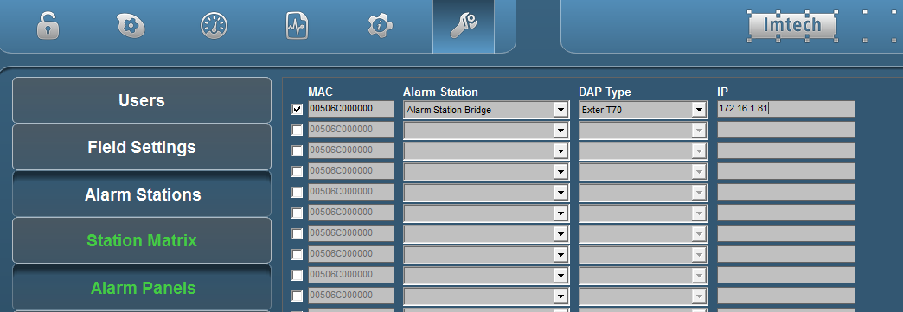

Figure 4‑4: Alarm panel setup